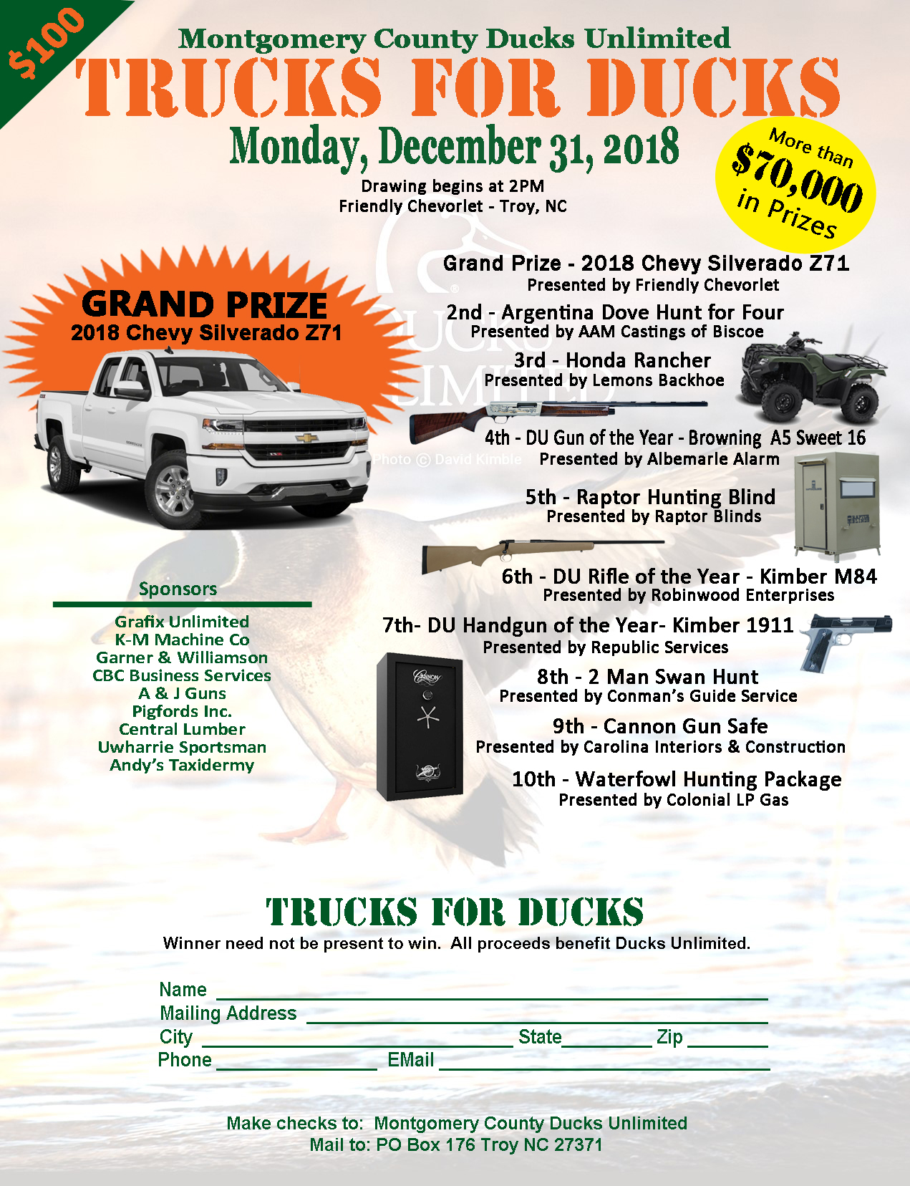
Trucks For Ducks
2018 Rules and Regulations
- Age limit for ticket purchasers is 18 years or older.
- 700 TICKETS MUST BE SOLD FOR THE 2018 CHEVY TRUCK TO BE ELIGIBLE FOR THE RAFFLE.
- IF 700 TICKETS ARE NOT SOLD THE GRAND PRIZE WILL BE A CASH PRIZE EQUAL TO TWENTY-FIVE (25) PERCENT OF TICKETS SOLD; UP TO TEN ($10) THOUSAND (MAXIMUM UNDER NC LAW).
- All other prizes will remain in the raffle no matter the amount of tickets sold.
- Montgomery County Ducks Unlimited makes no warranty, representation or guarantee, express or implied, in conjunction with any prize. No Raffle Prize substitution and no Raffle Prize transfer permitted. Raffle Prize cannot be redeemed /exchanged for cash or credit. All unspecified costs/expenses in conjunction with Raffle Prize are winner’s sole responsibility. Winner will be solely responsible for taxes on the fair market value of the Raffle Prize as this is ordinary income to the winner; and winner further understands that Montgomery County Ducks Unlimited is obligated to report winner’s receipt of Raffle Prize to appropriate governmental authorities in accordance with applicable law.
- Montgomery County Ducks Unlimited will cover the cost of title, transfer and sales taxes. All other Taxes, FEDERAL AND STATE INCOME TAXES are the responsibility of the winner. Winner will need a valid government-issued form of identification to claim their Raffle Prize if their ticket is selected in the Raffle. As well as a valid Social Security number and completed IRS form W9.
- The Raffle tickets will be available for purchase in person by eligible persons, by mail and online. Tickets purchased online will be mailed using the contact information provided by the ticket purchaser via USPS First Class Mail. Montgomery County Ducks Unlimited is not responsible for undeliverable tickets.
- Prize winners will have thirty (30) calendar days from the Draw Date to finalize the process of acquiring the Prize.
- Not need be present to win.
- If winner is not in attendance, he/she will be notified by phone, e-mail and/or registered mail using the contact information provided by the ticket purchaser and will be required to provide valid government-issued photo identification within five (5) days of initial contact.
- If selected winning entrant is unable to be contacted or located after a period of ten (10) days from the draw date he/she will forfeit the prize. Montgomery County ducks Unlimited shall have no liability to such person. Three (3) attempts will be made to contact the winning entrant via phone, email address and Registered Mail at the information provided by the entry purchaser.
- Entrants, by participating (and winners by accepting the prize) release Montgomery County Ducks Unlimited and its respective agents, Board, volunteers, partners, employees, members, service agencies, and independent contractors and each of their respective directors, officers, partners, employees and agents, including advertising and promotion agencies, from any and all liability with respect to participation in the promotion and possession or use of the prize awarded. Entrants will not hold Montgomery County Ducks Unlimited responsible or liable for any or all accidents, theft or damages resulting by their participation in this event. By purchasing a ticket, the entrant acknowledges and agrees to be bound by these rules and regulations.
- Entrants, by participating, agree to allow Montgomery County Ducks Unlimited. to use their names, photos and statements in promotional material. Montgomery County Ducks Unlimited will not share other personal information from entries with other organizations.
- REFUND POLICY: EXCEPT WHERE OTHERWISE INDICATED, TICKET PRICE IS NOT REFUNDABLE UNLESS Montgomery County Ducks Unlimited CANCELS RAFFLE.

